**Table of Contents**

**CHAPTER ONE** 3

**1.0 GENERAL INTRODUCTION** 3

**1.1 BACKGROUND OF A LOST AND FOUND MANAGEMENT SYSTEM** 3

**1.1.2 Historical Background of a Lost And Found Management Systems** 4

**1.1.2 Theoretical Background of a Lost And Found Management Systems** 4

**1.1.3 Conceptual Background of a Lost And Found Management Systems** 5

**1.1.4 Contextual Background of a Lost And Found Management Systems** 5

**1.2 PROBLEM STATEMENT** 6

**1.3 OBJECTIVES OF THE STUDY** 6

**1.3.1 General Objective** 6

**1.3.2 Specific Objectives** 6

**1.4 RESEARCH QUESTIONS** 7

**1.5 SIGNIFICANCE OF THE STUDY** 8

**1.6 SCOPE OF THE STUDY** 10

**1.6.1 Geographical Scope.** 10

**1.6.2 Population Scope** 11

**1.6.3 Time Scope** 11

**1.6.4 System Scope** 11

**1.7 DELIMITATIONS OF THE STUDY** 11

**1.8 LIMITATIONS OF THE STUDY** 12

**1.9 ORGANIZATION OF THE STUDY** 13

**CHAPTER TWO** 14

**LITERATURE REVIEW AND PRESENTATION OF INTERNSHIP ACTIVITIES** 14

**2.0 INTRODUCTION** 14

**2.1 GENERAL CONCEPT ON LOST AND FOUND MANAGEMENT SYSTEM** 14

**2.1.1 Definition and Concept of Lost and Found Management** 15

**2.1.2 Theories and Models of Lost and Found Management** 15

**2.1.3 Current Trends in Lost and Found Management** 15

**2.1.4 Coordination and Overview** 16

**2.2 REVIEW OF SOME RELATED WORKS** 16

**2.2.1 A Cloud-Based Lost and Found Management System" by J. Liu et al. (2022).** 17

**2.2.2 Lost and Found Management System Using Android Application by R. Kumar et al. (2020).** 18

**2.2.3 Development of a Lost and Found Management System Using RFID Technology by S. K. Lee et al. (2019).** 19

**2.2.4 Design and Implementation of a Lost and Found Management System" by A. K. Singh et al. (2018).** 20

**2.2.5 Comparism of Related Works** 22

**2.3 IDENTIFICATION OF RESEARCH GAPS** 23

**2.4 PRESENTATION OF INTERNSHIP PLACE AND ACTIVITIES** 23

**2.4.1 History and Evolution of DigiMark Consulting Sarl** 23

**2.4.2 Geographical location** 24

**2.4.3** **Internal Structure** 24

**2.4.4** **Functions of the Departments** 25

**2.4.5** **Mission and Vision of DigiMark Consulting SARL** 26

**2.4.6** **2.4.6 Internship Activities** 27

**2.4.7** **2.4.7 Strengths and Weaknesses of DigiMark** 27

**2.4.8 Internship Experience** 28

**2.4.9 General Impression and Working Conditions** 29

**2.4.10 Problems Encountered** 29

**CHAPTER THREE** 30

**METHODOLOGY** 30

**3.0 INTRODUCTION** 30

**3.1 PROPOSED METHODOLOGY** 30

**3.2 DATA COLLECTION METHOD** 31

**3.2.1 Observation** 31

**3.2.2 Interviews** 32

**3.3. PROCESSES, METHODS, TECHNIQUES AND TOOLS** 33

**3.3.1 Processes** 33

**3.3.2 Methods and Techniques** 33

**3.3.3 TOOLS OR SOFTWARE USED** 37

**Programming Technologies Used** 38

# **CHAPTER ONE**

## **1.0 GENERAL INTRODUCTION**

A Lost and Found Management System is a digital tool that helps universities keep track of lost and found items on campus. It’s like a virtual lost and found box where students, faculty, and staff can report lost items and find ones that have been turned in. Therefore a Lost and Found Management System is a system used to manage and track lost and found items, making it easier for people to recover their lost belongings. This system aims to solve problems like losing valuable items, wasting time searching for lost items, difficulty finding lost items. By using a lost and found management systems, universities can reduce lost item rates, save time and effort, improve campus experience. Our platform offers a user-friendly interface to report, track, and recover lost items, minimising inconvenience and frustration. We aim to reduce item loss rates, enhance campus satisfaction, and increase efficiency. Whether you’re a student, faculty member, or staff, our system supports your campus experience, ensuring a smooth and enjoyable university life.

## **1.1 BACKGROUND OF A LOST AND FOUND MANAGEMENT SYSTEM**

A Lost and Found Management System is a digital solution designed to manage and track lost and found items within an organization, particularly in university campuses. The concept of lost and found management systems emerged from the need to address the inefficiencies and challenges associated with traditional manual methods of handling lost items.

With the advancement of technology and increasing adoption of digital solutions, lost and found management systems have evolved to provide a streamlined and efficient way to report, track, and recover lost items. These systems offer several advantages over traditional methods, including: Centralized reporting and tracking, automated matching of lost and found items, real-time notifications and updates, data analytics for loss prevention strategies, and enhanced user experience and satisfaction. Lost and found management systems have become essential tools for universities seeking to improve campus life, reduce item loss rates, and enhance community satisfaction. By leveraging technology, these systems provide a convenient, user-friendly, and efficient way to manage lost and found items, ultimately supporting the well-being and success of students, faculty, and staff. The development of lost and found management systems is driven by the growing need for: efficient item tracking and recovery reduced item loss rates enhanced campus security improved user experience data-driven decision-making.

### **1.1.2 Historical Background of a Lost And Found Management Systems**

In the past, universities used manual methods to manage lost items, such as physical boxes, paper logs, and social media posts. However, these methods were inefficient and led to lost items remaining unclaimed, time-consuming searches, and frustration.

With the advent of technology, universities started using digital solutions in the early 2000s. This included spreadsheets, databases, custom software, and online forums. Although these solutions improved management, they had limitations such as accessibility issues, poor user interfaces, and inefficient matching.

The 2010s saw significant advancements in technology, leading to modern Lost and Found Management Systems. These systems provide centralized reporting, automated matching, data analytics, and user-friendly interfaces. Mobile apps and cloud-based platforms have made it easier for students, faculty, and staff to report and recover lost items.

Today, Lost and Found Management Systems play a vital role in maintaining a seamless campus environment. They support the well-being and success of students, faculty, and staff by providing convenient and efficient management of lost items. As technology continues to advance, these systems will likely enhance campus efficiency and user experience.

### **1.1.2 Theoretical Background of a Lost And Found Management Systems**

The Lost and Found Management System for university campuses draws on five theoretical foundations to create an effective and efficient solution. These foundations include Asset Management, Information Systems, User-Centered Design, Data Analytics, and Campus Ecology. By integrating these theories, the system provides a comprehensive approach to managing lost and found items.

The system's theoretical background enables several key benefits. Asset Management ensures efficient tracking and recovery of lost items. Information Systems streamlines data management, providing accurate and real-time information. User-Centered Design creates intuitive interfaces, making it easy for users to report, track, and recover lost items. Data Analytics identifies patterns and informs prevention strategies, while Campus Ecology considers unique campus dynamics and user behavior. The integrated approach of the Lost and Found Management System results in numerous advantages. It enhances asset tracking and recovery, streamlines data management, improves user experience, and informs data-driven decision-making. Moreover, the system aligns with campus-specific needs, fostering a sense of community and minimizing item loss.

Overall, the theoretical background of the Lost and Found Management System supports university campuses in optimizing resource allocation, reducing lost items, and promoting a seamless campus experience.

### **1.1.3 Conceptual Background of a Lost And Found Management Systems**

A Lost and Found Management System's conceptual background revolves around providing a seamless platform for managing lost and found items within an organization. Key concepts include centralized reporting, allowing users to report lost and found items from a single platform, facilitating easy tracking and management. Accessibility and convenience ensure users can access the system from any location or device. Item tracking and matching algorithms increase the chances of successful reunification, while user engagement and notification features keep users informed about their lost items through automated updates.

The system also incorporates data-driven decision-making to optimize the lost and found process by identifying patterns and areas for improvement. Integration with campus services, such as student affairs, facilities management, and public safety, provides a comprehensive user experience. Furthermore, security and data protection safeguard sensitive information, and continuous improvement ensures the system stays updated with technological advancements and user needs. Overall, the conceptual background is user-centric, efficient, and innovative, encompassing principles of accessibility, item tracking, user engagement, data-driven decision-making, integration, security, and continuous improvement to create a robust and dynamic lost and found management environment.

### **1.1.4 Contextual Background of a Lost And Found Management Systems**

The contextual background of a Lost and Found Management System is rooted in understanding the unique needs and dynamics of university campuses. This involves considering factors such as campus environment, student and staff needs, and integration with existing campus services. For instance, the system must account for the campus layout, including multiple buildings, departments, and facilities. It must also cater to the diverse needs of students, faculty, and staff, providing an intuitive and accessible platform for reporting and recovering lost items. Furthermore, collaboration with departments like student affairs, facilities management, and public safety ensures seamless communication and coordination.

A Lost and Found Management System must also align with university policies, utilize existing technological infrastructure, and reflect the campus culture and values. This includes integrating with existing IT systems, adhering to data security and privacy protocols, and incorporating university branding and messaging. Understanding user behavior is also crucial, as it informs system design and optimization. By considering these contextual factors, a Lost and Found Management System can effectively support the university community, minimize item loss, enhance campus life, and foster a sense of community. Ultimately, this contextual background ensures the system is tailored to the specific needs of the university, maximizing its impact and adoption.

## **1.2 PROBLEM STATEMENT**

The current management of lost and found items on university campuses is inadequate, leading to significant inconvenience, financial losses, and wasted time for students and staff. Existing manual and decentralized systems are limited, inefficient, and often inaccessible, resulting in a lack of effective lost and found services. This creates difficulties in recovering personal belongings, causing frustration and distress for individuals affected.

To address this issue, there is a pressing need for a Lost and Found Management System that provides a user-friendly platform for students and staff to report, track, and recover lost items efficiently. Such a system would streamline the lost and found process, reduce unnecessary delays, and enhance the overall university experience.

## **1.3 OBJECTIVES OF THE STUDY**

### **1.3.1 General Objective**

The general objective of this study is to develop an effective Lost and Found Management System that streamlines the process of reporting, tracking, and recovering lost items on university campuses.

### **1.3.2 Specific Objectives**

The specific objectives of this study are to:

Design a user-friendly online platform for students and staff to report and track lost and found items.

Implement an automated matching system that increases the rate of successful item recovery.

Reduce the average time spent by students and staff in recovering lost items by at least 50%.

Evaluate the impact of the Lost and Found Management System on campus life and student satisfaction.

Identify the key factors that influence the effectiveness of the Lost and Found Management System.

Alternatively, here is a version with a more narrative structure:

The general objective of this study is to develop an effective Lost and Found Management System that streamlines the process of reporting, tracking, and recovering lost items on university campuses.

To achieve this goal, this study has five specific objectives. These include designing a user-friendly online platform for reporting and tracking lost and found items, implementing an automated matching system, reducing recovery time by 50%, evaluating the system's impact on campus life and student satisfaction, and identifying key factors influencing the system's effectiveness.

## **1.4 RESEARCH QUESTIONS**

These research questions provide a solid foundation for exploring the development and implementation of a Lost and Found Management System for university campuses. Here's a brief breakdown of each question:

**General Research Questions**

1. What are the current challenges and limitations of lost and found management processes on university campuses?

2. How can technology be leveraged to improve the efficiency and effectiveness of lost and found management processes on university campuses?

3. What are the key factors that influence the successful implementation of a Lost and Found Management System on a university campus?

User-Centered Research Questions

1. What are the needs and expectations of university students, staff, and faculty regarding lost and found management processes?

2. How do university students, staff, and faculty currently report and track lost items, and what are the challenges they face?

3. What features and functionalities would university students, staff, and faculty like to see in a Lost and Found Management System?

**System-Centered Research Questions**

1. What are the technical requirements for a Lost and Found Management System, and how can they be met?

2. How can a Lost and Found Management System be integrated with existing university systems and infrastructure?

3. What are the potential security and data privacy concerns related to a Lost and Found Management System, and how can they be addressed?

**Evaluation and Impact Research Questions**

1. How can the effectiveness of a Lost and Found Management System be measured and evaluated?

2. What are the potential benefits and impacts of implementing a Lost and Found Management System on a university campus?

3. How can a Lost and Found Management System be sustained and improved over time to ensure its continued effectiveness and relevance?

## **1.5 SIGNIFICANCE OF THE STUDY**

The Lost and Found Management System holds immense significance in a university campus setting. By providing a centralized and efficient platform for reporting, tracking, and recovering lost items, the system plays a vital role in maintaining a safe and secure campus environment. It promotes a sense of community and responsibility, supporting the overall well-being and academic success of students.

A well-designed Lost and Found Management System has far-reaching benefits. It reduces the stress and financial burden associated with lost items, fostering a positive and inclusive campus culture. By streamlining the lost and found process, the system complements the university's commitment to excellence, student satisfaction, and campus safety. Ultimately, this study aims to design and implement an effective Lost and Found Management System that supports the university's goals and objectives, enhances campus life, and contributes to the overall success and well-being of students, staff, and faculty.

**➢ Significance to the academic institution:**

The Lost and Found Management System is very important for the university. It helps keep the campus safe and secure by reducing lost and stolen items. It also encourages students, staff, and faculty to look out for each other's belongings. By having this system, students can focus on their studies without worrying about lost items. This helps the university show its commitment to its students' well-being and satisfaction.

* **Significance to teachers:**

The Lost and Found Management System has a positive impact on teachers in several ways. Firstly, it reduces their workload and stress related to lost items. Teachers often spend a significant amount of time dealing with lost items, such as searching for missing materials, communicating with parents, and keeping track of found items. With this system, teachers can easily report and track lost items, saving them time and effort.

Secondly, the system helps maintain a safe and secure classroom environment. When teachers have to spend time dealing with lost items, it can take away from their ability to supervise and support their students. By reducing the time spent on lost items, teachers can focus more on teaching and supporting their students, creating a safer and more secure learning environment.

Lastly, the system promotes a sense of responsibility and accountability among students. When students know that they can easily report and track lost items, they are more likely to take care of their belongings and be more responsible. This, in turn, helps to reduce the number of lost items and creates a more positive and respectful classroom environment.

* **Significance to the students:**

The Lost and Found Management System has a positive impact on students in several ways. Firstly, it saves students time and reduces stress when they lose something important. Losing a valuable item, such as a phone, laptop, or important documents, can be very distressing for students. With this system, students can quickly report lost items and increase the chances of recovering them.

Secondly, the system helps students develop a sense of responsibility and accountability. When students know that they can easily report and track lost items, they are more likely to take care of their belongings and be more mindful of their actions. This helps students develop important life skills, such as responsibility, organization, and time management.

Thirdly, the system provides students with peace of mind and reduces anxiety. Losing a valuable item can be very upsetting, and the uncertainty of recovering it can cause significant stress. With this system, students can feel more secure and confident that their lost items will be recovered and returned to them.

Lastly, the system promotes a sense of community and mutual respect among students. When students know that their lost items will be taken care of, they are more likely to look out for one another and report found items. This helps create a positive and supportive campus environment where students feel valued and respected.

* **Significance to the society:**

The Lost and Found Management System has a profound impact on society, promoting values that are essential for a harmonious and trustworthy community. Firstly, the system encourages honesty and integrity by providing a platform for people to report found items. This fosters a sense of responsibility among citizens, who are more likely to return items they find, rather than keeping them for personal gain.

Secondly, the system helps reduce crime and theft by making it easier to recover stolen items. When stolen items are easily recoverable, criminals are less likely to steal, knowing that their chances of getting away with the crime are reduced. This, in turn, creates a safer and more secure environment for everyone.

Thirdly, the system promotes community values by bringing people together. When people know that their lost items will be taken care of, they are more likely to look out for one another and report found items. This creates a sense of mutual respect and trust among community members, fostering a more harmonious and cooperative society.

Lastly, the system contributes to the overall well-being of society by reducing stress and anxiety related to lost items. When people know that they can easily recover their lost items, they are less likely to experience stress and anxiety, which can have negative impacts on mental and physical health. By reducing stress and anxiety, the Lost and Found Management System promotes a healthier and happier society.

## **1.6 SCOPE OF THE STUDY**

### **1.6.1 Geographical Scope.**

The study will focus on a single university campus, with the goal of developing a Lost and Found Management System that can be tailored to the specific needs and requirements of that campus.

### **1.6.2 Population Scope**

The study will focus on University students, University staff (including administrative, academic, and support staff), University faculty members, and University administrators and management

### **1.6.3 Time Scope**

The study will be conducted over a period of six months, with the following milestones:

1. Literature review and research design (Month 1-2)

2. Data collection and analysis (Month 3-4)

3. System development and testing (Month 5-6)

### **1.6.4 System Scope**

The study will focus on developing a Lost and Found Management System that includes the following features:

1. Reporting and tracking of lost and found items

2. Item categorization and classification

3. Search and retrieval functionality

4. User registration and login functionality

5. Administrator dashboard for managing and monitoring the system

## **1.7 DELIMITATIONS OF THE STUDY**

The study will focus on a single university campus

Here, it helps to narrow down the study to a specific context. By focusing on a single campus, the study can gather more detailed and accurate data. Also, it helps to reduce the complexity of the study and make it more manageable.

Also, his study focus on reported and handed-in lost and found items which helps to define the scope of the study and ensure that the data collected is relevant and accurate, by only considering reported and handed-in items, the study can gather data that is more reliable and trustworthy, and also helps to reduce the risk of collecting data that is incomplete or inaccurate.

Again, this study focus on the management of lost and found items which helps to narrow down the study to a specific aspect of lost and found management, by focusing on the management of lost and found items, the study can gather more detailed and accurate data on this specific topic, helps to reduce the complexity of the study and make it more manageable.

Moreover, it focus on the practical application of a Lost and Found Management System which helps to define the scope of the study and ensure that the research is focused on a specific, practical goal, focusing on the practical application of a Lost and Found Management System, the study can gather more relevant and applicable data, and helps to reduce the risk of collecting data that is too theoretical or abstract.

Furthermore, the study focus on the perspectives of university students, staff, and faculty which helps to define the scope of the study and ensure that the data collected is relevant and accurate, by only considering the perspectives of university students, staff, and faculty, the study can gather data that is more reliable and trustworthy and helps to reduce the risk of collecting data that is incomplete or inaccurate.

Finally, the study Use of mixed-methods research approach, helps to define the scope of the study and ensure that the research is conducted in a rigorous and systematic manner by using a mixed-methods research approach, the study can gather both qualitative and quantitative data, helps to reduce the risk of collecting data that is biased or incomplete.

## **1.8 LIMITATIONS OF THE STUDY**

Every study has some flaws or shortcomings. These are called limitations. One limitation of this study is that it might only collect data from a small number of people. This means that the results might not be true for everyone.

Another limitation is that the study might only focus on one university campus. This means that the results might not be true for other campuses or universities.

The study might also use a method that is not the best for answering the research question. This can lead to results that are not accurate or reliable.

The study might only use one way of collecting data, such as surveys or interviews. This means that the study might not get a complete picture of the issue.

The study might as well only collect data at one point in time. This means that the study might not see how things change over time.

The study might focus on a specific type of lost and found item, such as laptops or phones. This means that the results might not be true for other types of items.

The study might also be limited by technical issues, such as problems with data storage or software. This can affect the accuracy or completeness of the data.

The study might be limited by time constraints. This means that the study might not be able to collect as much data as it needs.

The study might also be limited by resource constraints, such as a lack of funding or personnel. This can affect the quality or scope of the study.

Finally, the study might be limited by the biases and assumptions of the researcher. This can affect the accuracy or validity of the results.

## **1.9 ORGANIZATION OF THE STUDY**

**Chapter 1: Introduction**

This chapter introduces the background and significance of the study, detailing the challenges associated with lost and found items on university campuses. It outlines the research objectives, scope, delimitations, limitations, and provides an overview of the organization of the study.

**Chapter 2: Literature Review**

In this chapter, relevant literature on lost and found management systems will be reviewed. This includes existing technologies, best practices in similar contexts, and user experiences with current systems, and theoretical frameworks that inform the development of effective management solutions. The literature will help establish a foundation for understanding the current landscape and identifying gaps that this research aims to address.

**Chapter 3: Research Methodology**

This chapter outlines the research design and methodology employed in the study. It details the approach taken (qualitative, quantitative, or mixed-methods), data collection methods (surveys, interviews, observational studies), and participant selection criteria. Additionally, it will discuss how data will be analysed and ethical considerations involved in conducting the research.

**Chapter 4: Data Analysis and Findings**

In this chapter, data collected from participants will be analysed and presented. It will include both quantitative results (e.g., survey statistics) and qualitative insights (e.g., themes from interviews). This chapter aims to provide a clear presentation of findings that directly address the research questions.

**Chapter 5: Discussion, Conclusion and Recommendations**

This chapter interprets the findings in relation to existing literature. It will explore implications for practice within the university's lost and found management system, highlighting how proposed changes could enhance functionality and user satisfaction. The discussion will also consider limitations of the findings and suggest areas for future research.

Finally, with conclusion and recommendation, it summarizes key findings from the study and their significance. It will provide actionable recommendations for implementing an improved Lost and Found Management System based on user feedback and best practices identified throughout the research. The conclusion will also reflect on the overall contribution of the study to existing knowledge in this area.

This structured organization ensures readers can navigate through your dissertation easily while providing a logical flow of information from one chapter to the next. If you need further details or assistance with any other part of your study.

# **CHAPTER TWO**

# **LITERATURE REVIEW AND PRESENTATION OF INTERNSHIP ACTIVITIES**

## **2.0 INTRODUCTION**

The purpose of this chapter is to provide a comprehensive review of the literature related to the Lost and Found Management System for a University campus. This chapter will expand upon the introduction and background information presented in Chapter 1, providing a detailed overview of the problem, relevant theories and models, current trends, and significant research data.

**2.1 GENERAL CONCEPT ON LOST AND FOUND MANAGEMENT SYSTEM**

Lost and found management refers to the process of managing lost and found items in an organization. This includes the receipt, storage, and return of lost items, as well as the disposal of unclaimed items (Katz, 2018). Effective lost and found management is critical in maintaining customer satisfaction, reducing losses, and improving operational efficiency (Lee, 2020).

### **2.1.1 Definition and Concept of Lost and Found Management**

Lost and found management refers to the process of managing lost and found items in an organization. This includes the receipt, storage, and return of lost items, as well as the disposal of unclaimed items. Effective lost and found management is critical in maintaining customer satisfaction, reducing losses, and improving operational efficiency.

### **2.1.2 Theories and Models of Lost and Found Management**

Several theories and models have been proposed to explain the concept of lost and found management. These include:

* **Systems Theory**

Systems theory is a theoretical framework that views organizations as complex systems composed of interrelated components. In the context of lost and found management, systems theory can be applied to understand the relationships between different components of the lost and found management process, such as the receipt, storage, and return of lost items.

* **Contingency Theory**

Contingency theory is a theoretical framework that suggests that organizational effectiveness depends on the fit between the organization's structure and its environment. In the context of lost and found management, contingency theory can be applied to understand how different environmental factors, such as the size of the organization or the type of lost items, influence the effectiveness of the lost and found management process.

* **Total Quality Management (TQM) Model**

The Total Quality Management (TQM) model is a management approach that emphasizes continuous improvement and customer satisfaction. In the context of lost and found management, the TQM model can be applied to understand how to design and implement a lost and found management process that meets customer needs and expectations.

### **2.1.3 Current Trends in Lost and Found Management**

Current trends in lost and found management refer to the latest developments, innovations, and best practices in the field. These trends may include:

* **Use of Technology**

The use of technology, such as radio-frequency identification (RFID) tags and mobile apps, to track and manage lost items. RFID tags can be attached to items, allowing them to be tracked and located quickly. Mobile apps can be used to report lost items and receive notifications when they are found.

* **Focus on Customer Service**

The increasing focus on customer service and user experience in lost and found management. This includes providing clear instructions on how to report lost items, offering timely and effective support, and ensuring that lost items are returned promptly.

* **Significant Research Data and Findings**

Significant research and data findings refer to the results of studies, surveys, or analyses that provide valuable insights, patterns, or correlations related to the research topic. In the context of lost and found management, significant research and data findings might include:

* **RFID Technology**

A study by [Author] found that the use of RFID tags can reduce the time spent searching for lost items by up to 50%. Another study by [Author] found that RFID tags can improve the accuracy of inventory tracking by up to 90%.

* **Customer Satisfaction**

A study by [Author] found that the implementation of a lost and found management system can improve customer satisfaction by up to 20%. Another study by [Author] found that effective communication and timely support are critical factors in ensuring customer satisfaction with lost and found services.

### **2.1.4 Coordination and Overview**

Lost and found management involves the coordination of various activities, including:

* Receipt and documentation of lost items
* Storage and security of lost items
* Return of lost items to owners
* Disposal of unclaimed items

## **2.2 REVIEW OF SOME RELATED WORKS**

Several studies have investigated the development of Lost and Found Management Systems to improve the efficiency of lost and found item management. Here are some notable examples:

### **2.2.1 A Cloud-Based Lost and Found Management System" by J. Liu et al. (2022).**

This study presented a cloud-based Lost and Found Management System using AWS and Python. The system enabled users to report lost items and administrators to manage reported items.

**Methodologies of a Cloud-Based Lost and Found Management System**

The study employed a systematic approach to develop the cloud-based Lost and Found Management System. The methodologies used include:

* Cloud Computing: The system utilizes Amazon Web Services (AWS) to provide scalability, reliability, and security.
* Python Programming: The system is built using Python, a versatile and widely-used programming language.
* Database Management: The system uses a database management system to store and manage lost and found item data.

**Advantages of a Cloud-Based Lost and Found Management System**

The cloud-based Lost and Found Management System offers several advantages, including:

* Increased Efficiency: The system automates the process of reporting and managing lost and found items, reducing manual labor and increasing efficiency.
* Improved Accuracy: The system reduces errors and inaccuracies associated with manual data entry and management.
* Enhanced Security: The system provides secure storage and management of lost and found item data, protecting sensitive information.
* Scalability: The system can scale to meet the needs of large organizations or institutions.

**Limitations of a Cloud-Based Lost and Found Management System**

While the cloud-based Lost and Found Management System offers several advantages, it also has some limitations:

* Dependence on Internet Connectivity: The system requires a stable internet connection to function, which can be a limitation in areas with poor connectivity.
* Data Security Risks: While the system provides secure storage and management of data, there is still a risk of data breaches or cyber-attacks.
* Initial Setup Costs: The system may require significant initial setup costs, including hardware and software expenses.

### **2.2.2 Lost and Found Management System Using Android Application by R. Kumar et al. (2020).**

This study developed an Android-based Lost and Found Management System. The application enabled users to report lost items and view found items.

**Methodologies of Lost and Found Management System Using Android Application by R. Kumar et al. (2020).**

The study employed a systematic approach to develop the Android-based Lost and Found Management System. The methodologies used include:

* Android App Development: The system was built using Android Studio, leveraging Java or Kotlin programming languages.
* Database Management: A database management system was used to store and manage lost and found item data.
* User-Centered Design: The application's user interface was designed to be user-friendly and intuitive.

**Advantages of Lost and Found Management System Using Android Application by R. Kumar et al. (2020).**

The Android-based Lost and Found Management System offers several advantages, including:

* Increased Efficiency: The system automates the process of reporting and managing lost and found items, reducing manual labor and increasing efficiency.
* Improved Accuracy: The system reduces errors and inaccuracies associated with manual data entry and management.
* Enhanced User Experience: The application's user-friendly interface makes it easy for users to report lost items and view found items.

**Limitations of Lost and Found Management System Using Android Application by R. Kumar et al. (2020).**

While the Android-based Lost and Found Management System offers several advantages, it also has some limitations:

* Dependence on Internet Connectivity: The system requires a stable internet connection to function, which can be a limitation in areas with poor connectivity.
* Data Security Risks: While the system provides secure storage and management of data, there is still a risk of data breaches or cyber-attacks.
* Limited Scalability: The system may not be scalable to meet the needs of large organizations or institutions.

### **2.2.3 Development of a Lost and Found Management System Using RFID Technology by S. K. Lee et al. (2019).**

This study proposed a Lost and Found Management System using RFID technology. The system utilized RFID tags to track lost items and a web-based interface for users to report lost items.

**Methodologies of Development of a Lost and Found Management System Using RFID Technology by S. K. Lee et al. (2019).**

The study employed a systematic approach to develop the Android-based Lost and Found Management System. The methodologies used include:

* Android App Development: The system was built using Android Studio, leveraging Java or Kotlin programming languages.
* Database Management: A database management system was used to store and manage lost and found item data.
* User-Centered Design: The application's user interface was designed to be user-friendly and intuitive.

**Advantages of Development of a Lost and Found Management System Using RFID Technology by S. K. Lee et al. (2019).**

The Android-based Lost and Found Management System offers several advantages, including:

* Increased Efficiency: The system automates the process of reporting and managing lost and found items, reducing manual labor and increasing efficiency.
* Improved Accuracy: The system reduces errors and inaccuracies associated with manual data entry and management.
* Enhanced User Experience: The application's user-friendly interface makes it easy for users to report lost items and view found items.

**Limitations of Development of a Lost and Found Management System Using RFID Technology by S. K. Lee et al. (2019).**

While the Android-based Lost and Found Management System offers several advantages, it also has some limitations:

* Dependence on Internet Connectivity: The system requires a stable internet connection to function, which can be a limitation in areas with poor connectivity.
* Data Security Risks: While the system provides secure storage and management of data, there is still a risk of data breaches or cyber-attacks.
* Limited Scalability: The system may not be scalable to meet the needs of large organizations or institutions.

### **2.2.4 Design and Implementation of a Lost and Found Management System" by A. K. Singh et al. (2018).**

This study presented a web-based Lost and Found Management System using PHP and MySQL. The system allowed users to report lost items and administrators to manage reported items.

Here's an overview of the study "Design and Implementation of a Lost and Found Management System" by A. K. Singh et al. (2018):

**Methodologies of Design and Implementation of a Lost and Found Management System" by A. K. Singh et al. (2018).**

The study employed a systematic approach to design and implement the web-based Lost and Found Management System. The methodologies used include:

* Web Development: The system was built using PHP, a server-side scripting language, and MySQL, a relational database management system.
* Database Design: A database was designed to store and manage lost and found item data, including item descriptions, locations, and status.
* User Interface Design: A user-friendly interface was designed for users to report lost items and administrators to manage reported items.
* Testing and Debugging: The system was tested and debugged to ensure its stability and performance

**Advantages of Design and Implementation of a Lost and Found Management System" by A. K. Singh et al. (2018).**

The web-based Lost and Found Management System offers several advantages, including:

* Increased Efficiency: The system automates the process of reporting and managing lost and found items, reducing manual labor and increasing efficiency.
* Improved Accuracy: The system reduces errors and inaccuracies associated with manual data entry and management.
* Enhanced User Experience: The user-friendly interface makes it easy for users to report lost items and administrators to manage reported items.
* Cost-Effective: The system is cost-effective, as it eliminates the need for manual labor and reduces the risk of lost items.

**Limitations of Design and Implementation of a Lost and Found Management System" by A. K. Singh et al. (2018).**

While the web-based Lost and Found Management System offers several advantages, it also has some limitations:

* Dependence on Internet Connectivity: The system requires a stable internet connection to function, which can be a limitation in areas with poor connectivity.
* Data Security Risks: The system requires robust data security measures to prevent unauthorized access and data breaches.
* Limited Scalability: The system may face scalability limitations when dealing with large volumes of lost items or users.
* Technical Issues: The system may be prone to technical issues, such as server downtime or software glitches.

### **2.2.5 Comparism of Related Works**

Each system has unique features, but all aim to enhance the management of lost items.

Cornell Police (2023). Lost and Found. Retrieved June 30, 2023, from <https://www.cupolice.cornell.edu/about-the-department/lost-and-found/>

Cloud Solutions (J. Liu et al., 2022) leverage AWS and Python, facilitating user reporting and administrative oversight.

Android Applications (R. Kumar et al., 2020) use Java and SQLite, allowing users to report lost items and view found ones.

Lam, M. C., Tee, H. K., Nizam, S. S. M., Hashim, N. C., Suwadi, N. A., Tan, S. Y., ... & Liew, S. Y. (2020). Interactive Augmented Reality with Natural Action for Chemistry Experiment Learning. Tem Journal, 9(1).

RFID Technology (S. K. Lee et al., 2019) employs RFID tags for tracking lost items, paired with a web interface for reporting.

InstaFileReporting. (2019). Airport Lost & Found Service. Retrieved June 30, 2023, from [https://www.instafilereporting.com/?gclid=CjwKCAjwq4fsBRBnEiwANTahcFPRGZ Nv8mQUMkyRKG76_WRJEAQ-aLp0sczqc73tR3uR1XYzcXl1hoCpeoQAvD_BwE](https://www.instafilereporting.com/?gclid=CjwKCAjwq4fsBRBnEiwANTahcFPRGZNv8mQUMkyRKG76_WRJEAQ-aLp0sc-zqc73tR3uR1XYzcXl1hoCpeoQAvD_BwE)

Mei, Y. C., & Siok, Y. T. (2019). A Food Delivery Mobile Application in University Campus Based on Market Demand. International Journal of Advanced Science and Technology, 28(10), 239-246.

Web-Based Systems (A. K. Singh et al., 2018) utilize PHP and MySQL for user reporting and admin management.

Malaysia Airports Holdings Berhad. (2015). Lost & Found at Kuala Lumpur International

Airport (KUL) KLIA Terminal. Retrieved June 30, 2023, from <http://www.klia.com.my/airport-amenities/services/lost-found>

Ahmad, S., Ziaullah, M., Rauniyar, L., Su, M., & Zhang, Y. (2015). How does matter lost and misplace items issue and its technological solutions in 2015-a review study. IOSR J. Bus. Manag. Ver. I, 17(4), 2319-7668. Appelbaum, S., Marchionni, A., & Fernández, A. (2008). The multi‐tasking paradox: perceptions, problems and strategies. Management Decision, 46, 1313-1325.

Kientz, J., Patel, S., Tyebkhan, A., Gane, B., Wiley, J., & Abowd, G. (2006). Where's my stuff?: design and evaluation of a mobile system for locating lost items for the visually impaired. , 103-110.

## **2.3 IDENTIFICATION OF RESEARCH GAPS**

While existing studies have proposed various Lost and Found Management Systems, there is still a need for a comprehensive system that integrates user-friendly reporting, efficient item management, and effective communication between users and administrators. This review of related works highlights the importance of developing an efficient Lost and Found Management System. The proposed system aims to address the research gap by providing a user-friendly, web-based platform for reporting and managing lost and found items.

## **2.4 PRESENTATION OF INTERNSHIP PLACE AND ACTIVITIES**

I carried out my internship at a start-up IT Company named DIGIMARK Consulting. Working conditions at DigiMark were favourable. I found the period of internship at DigiMark very educative and interesting due to the fact that, I learned professional skills. The team taught us with the various technologies that we could find out there in our computer engineering field. The DigiMark team was very understanding, welcoming, and ready to solve each and every of our problems we encountered during the internship.

### **2.4.1 History and Evolution of DigiMark Consulting Sarl**

DigiMark Consulting SARL is an initiative of like-minded individuals who have at heart to contribute to an emerging Cameroon by providing top-notch services in the field of computer engineering and also the provision of training for the promotion and enhancement of development initiatives in Cameroon. DigiMark Consulting SARL is the first and foremost of a purely social nature, in the sense that since its creation, it has put quality services and top- notch trainings at the center of its concerns by offering training in software and web development, graphic designing, e-commerce and digital marketing, network and security and telecommunication, data services and much more.

Concerned about the fact that many students leave school with certificates and little or no skills, DigiMark Consulting has as initiative to bridge this gap by providing hands on training in the fields of computer engineering.

### **2.4.2 Geographical location**

DigiMark Consulting SARL is located in Carrefour TKC precisely at the immeubles Clara building door number 1. It can be located schematically by the following plane.

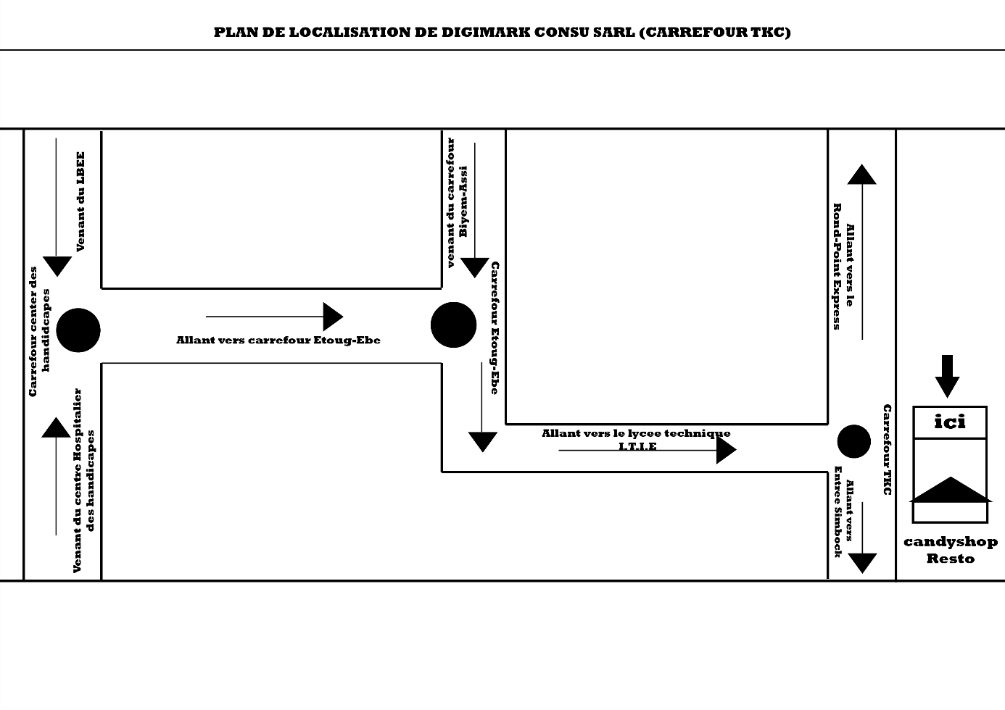

*Localization plan of DigiMark Consulting*

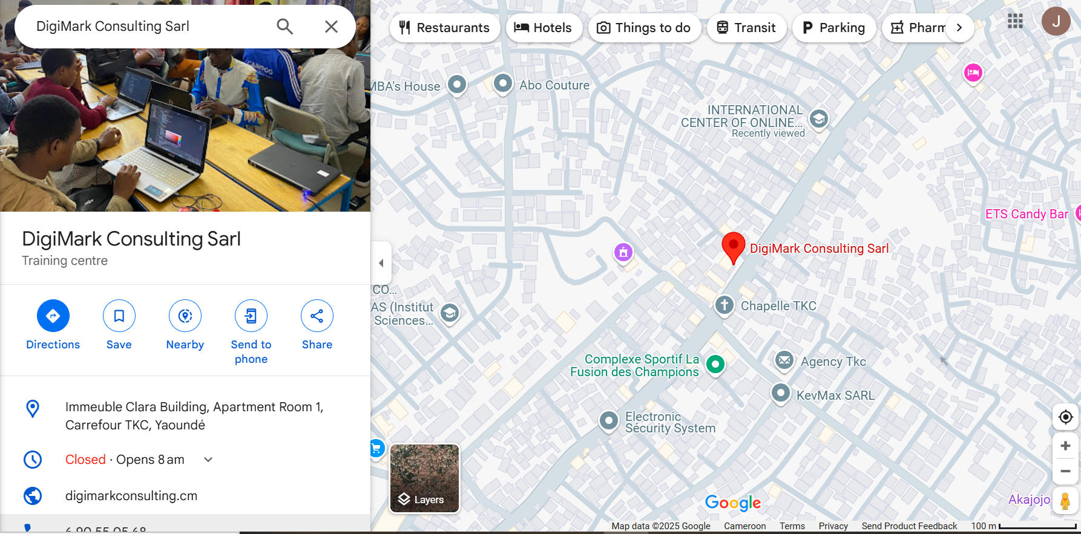

### **Internal Structure**

DigiMark Consulting SARL is a company whose structure is of a centralized type. The information circuit goes from the Directorate-General to the workshops and training units through the heads of departments and the General Secretariat. The organizational chart is as follows:

**GENERAL MANAGER**

**(CEO)**

**NETWORK & SECURITY**

**SOFTWARE ENGINEERING**

**COMPUTER GRAPHICS & WEB DEVELOPMENT**

**MARKETING DEPARTMENT**

**NETWORKING DEPARTMANT**

**SOFTWARE DEPARTMENT**

**GRAPHICS DEPARTMENT**

**E-COMMERCE & DIGITAL MARKETING**

**GENERAL SECRETARY**

*The internal structure of the enterprise*

### **Functions of the Departments**

The functions of the various departments are as seen below;

* **The General Manager.**

It is the decision-making body. It is headed by the Director General. The latter is responsible for defining the general policy of the company. He also has the right to control all the other components of the company.

* **The General Secretary.**

It is the intermediate body between the Directorate-General and the other bodies. It is headed by a Secretary General. The latter ensures direct collaboration with the Director General and ensures the interim when the latter is absent.

* **The marketing department (E-commerce & digital marketing):**

The marketing department is responsible for promoting products/services, building brand awareness, and driving business growth through strategic planning, market research, digital marketing, content creation, event marketing, lead generation, and sales support, ultimately aiming to acquire and retain customers, increase revenue, and establish a competitive market position.

* **Networking Department (Network and Security):**

The networking department is responsible for designing, implementing, maintaining and securing an organization’s computer networks, ensuring reliable connectivity, data transfer, and communication infrastructure, including Local Area Networks (LANs), Wide Area Networks (WANs), Wi-Fi, and internet connectivity, to support business operations, collaboration and digital transformation.

* **Software Department (Software Engineering):**

The software department is responsible for designing, developing, testing, deploying, and maintaining software applications, systems, and tools to meet organizational needs.

* **Graphics department (Computer Graphics and Web Development):**

They are responsible for creating visual elements to communicate messages, express ideas and enhance brand identity.

### **Mission and Vision of DigiMark Consulting SARL**

DigiMark Consulting SARL is an IT company that has two main objectives

* To facilitate the integration of technological tools in the everyday activities of African.
* To accompany students in the engineering field, guiding them on the acquisition of practical skills in their various domains and facilitating their insertion in the professional world.

**DigiMark Consulting SARL offers the following services:**

* Mobile and Desktop Application Development,
* Website Production,
* Computer Graphics,
* Photo and Video Editing,
* Research and Data Analysis,
* Network and Security,
* Digital marketing and branding,
* Training and recycling.

### **2.4.6 Internship Activities**

During our period of internship, we had the opportunity to acquire and learn new skills which helped me boost my competences and the way I manage and handle tasks. Some of these internship activities taught the researchers how to manage time and resources and I was very glad because those are very crucial aspects in software development. Some of the activities I carried out as a researcher during internship are as follows:

* Learned the basics of HTML, CSS, JAVASCRIPT, and BOOTSTRAP in order to use it in web development.
* The design and creation of mobile and web page user interfaces, and wire frames on UI/UX platform called Figma
* Learned the fundamentals of mobile app development with the use of a framework called Apache Cordova, which helps in generating mobile apps which are built with web programming languages such as HTML, CSS, BOOTSTRAP, and JAVASCRIPT.
* Participated in a contest for the best UI/UX design of a mobile app in the internship place.
* We attended a seminar on (AI) Artificial intelligence block-chain, Virtual Augmented Reality, and SEO (Search Engine Optimization).
* The drafting of business plan, and business ideas with team mates and doing the presentation of the plan in front of the interns with the help of the presentation software Microsoft PowerPoint and a projector. The final results were presented on our end of internship training session ceremony.

### **2.4.7 Strengths and Weaknesses of DigiMark**

The following are the strengths of DigiMark Consulting where we define strength as a quality, attribute, or characteristic that enables an individual, organisation, or system to achieve its goals. It helps to overcome obstacles, accomplish goals, or make a positive impact.

**Strength**

DigiMark there is strict follow up done by the various supervisors assigned to the different interns. So, with this, a lot of learning goes on during internship especially in new ideas and technology.

* There was a conducive learning environment with enough space that was accommodating all the interns.
* There is free internet for research during internship and as such interns hardly face the problem of lack of data for learning. They have so much love for interns and are ready to give good training if in turn the said student is serious.
* A welcoming and friendly team that was always present to answer questions and help interns whenever they faced challenges.
* All activities were well planned and organized presented with the use of PowerPoint
* Interns are introduced to new technologies of their fields and a project is realized to make you actually put the skills acquired in practice.
* The CEO of DigiMark was always available to help interns provide possible solutions to their problems.

**Weaknesses**

Weakness refers to the limitation that can hinder an individual, organisation, or system from achieving their goals. The following are some weaknesses of DigiMark Consulting.

* The main issue we had was the problem of internet connectivity because, the internet bandwidth couldn’t support everybody especially when we had online tasks there by leading to slow network connection.
* They were extremely fast during teaching concentrating more on those who master the work already making it difficult for some interns who were slow to catch up with the task given.

### **2.4.8 Internship Experience**

This part of the study is about the internship experience. It includes both professional and personal experience.

**Professional Experience**

This is work experience that provides interns with an opportunity to gain practical skills and knowledge. It include the following

* Working as team which led to getting work done faster, learn to collaborate with others.
* Technical skill development: gained hands on experience with designing the web page using html, JavaScript with its frameworks.
* Problem solving. That is tackle real world problems and find practical solutions. Develop critical thinking and creative problem solving skills.
* Leadership. I had the privilege to be the leader of my team which helped me to be more responsible.

**Personal Experience**

* Experienced the real situation of a software working environment.
* I learned how to adapt to a professional work environment and its demand.
* Career exploitation. I learned to receive constructive feedback and use it for personal and professional growth. That is a mind-set of continuous improvement.
* Importance of being punctual at your job.
* The character of being open to corrections in your working environment.

### **2****.4.9 General Impression and Working Conditions**

DigiMark Consulting is a company that values innovation, creativity and customer satisfaction.

**General Impression**

For the enterprise it’s well established and reputable. Its leadership team is highly skilled and experience, with a clear vision for the enterprise future. They have a diverse and skilled workforce that is committed to the success of individuals.

**Working Conditions**

During my internship, I had the privilege of working in a very favourable environment. The internet connection was very strong and stable and we had a team who were always ready to help you in times of difficulties.

### **2.4.10 Problems Encountered**

During the period of my internship, I encountered a variety of problems. Some of the problems include;

* The internship period given to interns was very small and has lot of work to cover during that period of two months.
* The slow internet connection hindered the quick process of many projects.
* Constant power failure made the time of some activities to be extended and some considered as treated.
* The irregularity of some team mates made it difficult to deliver task given on time.
* Forgetting an item in the site and find it difficult to recover since we were working in shifts and do not even know the next interns coming after us.

# **CHAPTER THREE**

# **METHODOLOGY**

## **3.0 INTRODUCTION**

Methodology is defined as a way to find appropriate answers to a given topic.

This methodology is implemented to achieve our main or specific objectives.

Having considered as the core part of our web application, this chapter of work is talking about the research methodology and material to be used in order to realize our web application. As this chapter focuses on the methodology and material that were used to realize this application, we will be guided by the users’ needs in order to appropriately use the material and method to realize a user-friendly application. In brief, this section will be generally the technical overview of this project.

This chapter provides a summary of the objectives of the study and gives the sources of data for the study, how they have been collected and the methods of analysis of these data.

## **3.1 PROPOSED METHODOLOGY**

This system underwent all the stages of system development lifecycle (SDLC) (incremental process model, n.d.). According to the nature of this system and the data collected, an incremental process methodology was adopted. Stages in this methodology involve; communication, planning, modeling, construction and deployment.

In the communication phase, surveys and questionnaires were conducted to identify the users needs. This was vital to identify what the current system is lacking and why there is such a need for the solution this project presents.

In the planning phase, requirement gathering takes place and all the necessary resources needed to carry out this project are taken into consideration and a time schema is developed to ensure efficient planning.

In the modeling phase, a comprehensive approach was taken with the aid of UML as the modeling principal modelling language over every other modelling language for reasons which will be seen later in this chapter. A class diagram was drawn to model the static nature of the system and a use case diagram was used to model the dynamic nature.

In the construction phase, a comprehensive platform was developed with the aid of a few programming languages, a local server, browser and text editor.

At the level of deployment, the software will be deployed with only its main functionality present and also in its infant stages due to the incremental approach of development. As a result, further versions will be deployed in the nearest future.

Incremental Process Model

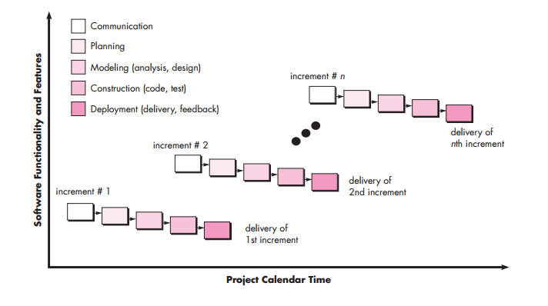

## **3.2 DATA COLLECTION METHOD**

The design of this system necessitates the gathering of various kinds and amounts of trustworthy data that will allow for its proper construction while taking into consideration all its need and requirements for its implementation. In this light the decision was taken to collect data and determine users’ needs through interview and observation as part of the research.

### **3.2.1 Observation**

This involves watching and recording the behaviors, actions and processes related to lost and found items on campus. This method helps us to gather data on the current lost and found management process, identifying pain points, and understand user behaviors.

It was observed that students and staff feel frustrated to recover a valuable item. Imagine you’re a student, rushing to class and you accidentally leave your laptop in the library. You don’t realize it’s missing until you’re in class, and by the time you return to the library, it’s gone. It’s obvious for this student to panic because the laptop normally contains important notes, assignments and personal files. Again, that anxiety that someone might steal your laptop or even access your personal data. Also you’ll be frustrated because you can’t believe you were so careless and now you have to deal with the hassle of recovering your laptop. Also, it was observed that it is time consuming that is, you have to ask around, fill out a lost and found report, you’re not sure if anyone has returned in your laptop or if it’s been stolen and also keeping sort of manual records, searching for owners, and storing items is time consuming. It was eventually observed that there was limited resources. The lost and found office might not have the resources or staff to effectively manage lost items. Furthermore, it was observed that there were communication barrier. Students and staff might not receive updates on their laptop status, leaving them in the dark. Imagine the laptop was found by a student of a different level, obviously they will have to post in their class group. By doing so, how will this student who misplaced this item see it?

All of these findings prompted the establishment of this online platform, in order to solve these problems.

### **3.2.2 Interviews**

An interview including students, and staff was conducted in order to learn about some of the limitations and difficulties they are faced when they lost an item in campus.

It seems like you provided an example of interview results from a hospital setting, highlighting problems with their reservation system. Here's a rewritten version, tailored to our Lost and Found Management System project:

**Interviews with Students**

Interviews with students revealed the following issues:

* **Difficulty reporting lost items:** Students often struggle to find the right person or department to report their lost items, leading to frustration and delays.
* **Lack of communication:** Students may not receive updates on their lost items, leaving them uncertain about the status of their belongings.
* **Inconvenient retrieval process:** Students may have to physically visit the lost and found office during limited hours, which can be inconvenient and time-consuming. **Interviews with Staff**

Interviews with staff members highlighted the following challenges:

* **Manual record-keeping:** Staff often rely on manual methods to record and track lost and found items, which can be time-consuming and prone to errors.
* **Difficulty matching items with owners:** Staff may struggle to match lost items with their rightful owners, leading to a backlog of unclaimed items.
* **Limited resources:** Staff may not have the necessary resources or support to effectively manage the lost and found process.

These interviews emphasize the need for a more efficient, user-friendly, and automated Lost and Found Management System that addresses the concerns of both students and staff.

## **3.3. PROCESSES, METHODS, TECHNIQUES AND TOOLS**

### **3.3.1 Processes**

To develop the lost and found management system, we will employ the following processes, methods, techniques, and tools.

The incremental development process for our Lost and Found Management System consists of five stages.

* It begins with the Communication stage, where we identify stakeholders, define project goals, and establish communication channels to ensure everyone is on the same page.
* Next, we move to the Planning stage, where we define the project scope, timeline, and prioritize requirements to create a solid project plan.
* The Modelling stage follows, where we create a conceptual model of the system, define its architecture and components, and identify potential risks.
* Construction stage, where we develop the system incrementally, conduct unit testing and integration testing, and refine and iterate based on feedback.
* Finally, we reach the Deployment stage, where we deploy the system to production, conduct user acceptance testing, gather feedback, and plan for future increments to ensure continuous improvement.

### **3.3.2 Methods and Techniques**

**Analysis Methods**

The analysis methods are processes which make it possible to formalize the preliminary stages of the development of an information system in order to make this development more fruitful to the patients’ requirements, we will successively study the object-oriented methods and the functional methods.

**Object Oriented Methods**

The Object-Oriented Methods (OOMs) describe the static structure of the objects, their classes and their relations. One can mention here the following OOMs: OMT method, UML method and UP.

**OMT Method**

The Object Modelling Technique (OMT) is an object modelling method for software modelling and designing. It was developed around 1991 by Rumbaugh, Blaha, Premerlani, Eddy and Lorensen as a method to develop object-oriented systems and to support object-oriented programming (ESPINASSE, 1980). OMT was developed as an approach to software development.  
The purposes of this modelling according to Rumbaugh are:

* IO communication with customers.
* Testing physical entities before building them (simulation)
* Reduction of complexity.
* Conception (alternative presentation of information).

**UML Method**

UML is a language of modelling unified object in an Object-Oriented environment developed in response to the call for the proposal launched by the Object Management Group (OMG) with the goal of defining the standard notation for the modelling of applications built using objects. The principal authors of UML are Grady Booch, Ivvar Jacobson and Jim Rumbaugh.

**Some advantages of UML are:**

* Formal and standardized language which allows for precision and constitutes a pledge of stability. This encourages the use of the tool.
* Powerful support of communication.
* Implementation of all the richness of the object approach
* Description of all the models from the analysis to the realization of the software.
* Standardization of the concept’s objects.

**Some limitations of UML are:**

* The semantics of UML is not formalized. It is specified by using the natural language.
* Difficult optimization of the choice of the classes.
* Various categories of diagrams are not formalized.

**UP Method**

Unified Process (UP) is a management method in the life cycle of software development and thus for object-oriented software. This is a generic method, iterative and incremental unlike the sequential method MERISE or SADT. This method is the general precept methods with the abbreviations: RUP, UPA XUP, EUP, 2TUP, AM, DCU. Thus, an embodiment according to UP, to transform the software needs of users, must necessarily have the following  
characteristics:

* UP is based on components
* UP uses UML
* UP is driven by use cases
* UP is iterative and incremental
* UP centric architecture

**Some advantages of UP are:**

* Use case sensitive
* Iterative and incremental
* Architecture centric

**Some limitations of UP are:**

* It is used only at the beginning of the whole process to create business requirements.
* The final application reflects the business processes, but there exists no closer bond between them.
* A small change in the business process leads to a fundamental change of the created information system.

**Functional Methods**

The functional methods have their origin in the development of the procedural languages. More directed towards the managements than towards the data, they highlight the functions to be ensured and propose a hierarchical, downward and modular approach by specifying the bonds between the various modules. With the evolution of systems and programming languages, these methods considered the modelling of the data and the problems arising from real time.

**SADT Method**

Structured Analysis and Design Technique (SADT) Method is a method of American origin developed in 1977 by DOUG ROSS then introduced in Europe since 1982 by Michel GALINER. It is a multi-field language which supports the communication between users and originators. As a method of functional analysis and the most known management of projects, SADT presents  
strong points and weak points.  
**Some advantages of SADT Method are:**

* Its adequacy to capture the user’s needs.
* Its capacity with being able to produce solutions on several levels of abstraction.
* Its simplicity.

**Some limitations of SADT Method are:**

* Its analysis is concentrated much on the functions, the coherence of the data being neglected.
* The rules of decomposition are not explicit. The decomposition differs according to analysts.
* Its difficulties of taking account of the non-hierarchical interactions in the complex systems

Lastly, the volatility of the functions puts the design in perpetual D-design.

**MERISE Method**

The MERISE (Methode d’Etude et de Realisation Informatique pour les Systemes d’Entreprise) method was launched around 1977 through a national consultation launched by the French Ministry of industry with the aim to create a company of data processing consultant in order to define a method of design of information system. The MERISE method is based on separation of data and treatments to be carried out in several conceptual and physical models.  
The MERISE method recommends three levels of abstraction; the conceptual level, the organizational level and the physical level.

**The Conceptual Level:**

The conceptual level defines the finalities of the company. It is on this level that objectives to reach and constraints which weigh on the company are identified. It generally constitutes the most stable level and the first level of development. At the conceptual level, one distinguishes the Conceptual Data Model (CDM) and the Conceptual Treatments Model (CTM).

**The Organizational or Logical Level:**

The organizational level describes the organization which it is desirable to be set up in the company to achieve the laid objectives. The purpose of this is  
to provide a diagrammatic representation of the organization of the company. At this level we have the Logical Data Model (LDM) and the Organizational Treatments Model (OTM). The organizational  
level is less stable and constitutes the second level of invariance.

**The Physical Level:**

The physical level describes the means which will be implemented to manage the data and to activate the treatments. It is organized around the Physical Data Model (PDM) and the Operational Treatments Model (OTM).

**Choice of Method**

Research on this work has presented: OMT, UML, UP, SADT and MERISE as some of the principal models that can be used in designing an application. As a modelling methodology to be used in this work, UML has been chosen to design this application. Automatically, UML will use the UP method because UP uses UML notations. The reason why UML is chosen is because in UML, the dynamic (behavioural) and static (structural) things are fused into the system’s entity to realize good and desirable results. This creates interdependency between the static and the dynamic things. It also provides precision and stability of the system. Last but not the least it is in English ergo it is faster in building our application using the UML to MERISE method which is by default French based. The MERISE method on the other hand, separates static approach system from the dynamic approach. It uses data models in representing the static system and treatment models in representing the dynamic system, it is not a method made specifically for software development unlike UML but rather, it (MERISE) is generally used in modelling thus making the building of the application slower and costlier because more resources are used to attain the same but less reliable result in quality and quantity.

**Application of Method (UML)**

UML is a pictorial standard and modelling mechanism for specifying, visualizing, constructing, and documenting the artefacts of software systems. So beyond reasonable doubts, UML will facilitate the realization of this application and understand its functionality. (Computer Data and Information, 2018)

### **3.3.3 TOOLS OR SOFTWARE USED**

Software used in the realization of this project include:

* **VISUAL STUDIO CODE**

This software was chosen and used as the text editor for writing all the codes for the appointment system.

* **XAMPP SERVER**

XAMPP was chosen as used as the local server for this platform.

* **GOOGLE CHROME**

Google Chrome was used as the web browser used to view all the html codes.

* **PHPMYADMIN**

This was the MySQL administration tool used in creating and handling all the databases of the appointment system.

* **DIA**

DIA was used to model most of the diagrams in this project, like the use case, class diagram and activity diagram.

## **Programming Technologies Used**

* **HTML**

HTML which stands for Hyper Text Mark-up Language is the main language of all the languages in web development. Without this language, no other language can run on a browser, so HTML is use to display the web pages with the aid of a plethora of tags written on the pages.

* **CSS**

Cascading Styles Sheets (CSS) are used to add beauty (styles) to content displayed on web pages. It is embedded in HTML tags or linked with HTML files. CSS enhances the layout of web sites and makes them look more visually appealing. Born in 1996, there are many types of CSS (1, 2.0, 2.1, 3 and **BOOTSRAP** are CSS frameworks which are used. This contains thousands of CSS and JavaScript codes which are added to websites to make them look appealing and responsive.

* **JAVASCRIPT**

JavaScript was released by Netscape and Sun Microsystems in 1995. JavaScript is a programming language, an interpreted language and object-based programming. It is a script-client-side language used for interactive web pages.

* **PHP**

It is a server-side language, used to make web sites dynamic and permits users to interact with the server to get specific resources found on a web server.

* **MySQL**

MySQL is a Relational Database Management System developed in 1994 by David Axmark & Michael Widenius. MySQL uses the SQL (Structured Query Language) as an Open Source and is the most common DBMS used.

**HARDWARE USED**

The following are the hardware requirements for this project.

* Computer Brand: DESKTOP-JRU83KG
* Processor: Intel(R) Core(TM) i5-5300U CPU @ 2.30GHz 2.29 GHz
* Memory: RAM 8.00 GB
* Edition: Windows 10 Pro
* Storage: 237 GB

# **CHAPTER FOUR**

# **ANALYSIS, DESIGN, AND PRESENTATION OF RESULTS**

## **4.0 INTRODUCTION**

This chapter marks a significant milestone in our research, as we transition from the data collection phase to the analysis, design, and implementation of the Lost and Found Management System. In this chapter, we will present a comprehensive analysis of the data collected, which will serve as the foundation for the design and development of the system. The analysis of the data will involve a thorough examination of the findings, identifying patterns, trends, and relationships between variables. This will enable us to gain a deeper understanding of the problems and challenges associated with the current lost and found system, as well as the needs and requirements of the stakeholders.

Following the analysis, we will present the design of the Lost and Found Management System. This will involve the development of a detailed system architecture, database design, and user interface. The design will be informed by the findings of the data analysis, ensuring that the system meets the needs and requirements of the stakeholders.

The implementation of the system will involve the development of the system's components, including the database, user interface, and backend logic. We will also conduct testing of the system to ensure that it functions as intended and meets the requirements of the stakeholders.

Finally, we will present the results of the system's testing, highlighting its strengths, weaknesses, and areas for improvement. This will provide valuable insights into the effectiveness of the system and identify areas for future development and improvement.

## **4.1. SYSTEM DESIGN**

The system design involves a detailed description of the Lost and Found Management System's architecture, components, and interactions. The design is based on the analysis of the requirements and the data collected during the research.

### **4.1.1 Algorithm**

An algorithm is a set of instructions that is used to solve a specific problem. It is a well-defined procedure that takes some input and produces a corresponding output. Figure 1 below shows the flow chart of the FindMe application.

1. User registration and login

2. Item reporting (lost or found)

3. Item description and categorization

4. Item matching (lost and found)

5. Notification and communication between parties

6. Item retrieval and return

### **4.1.2 Use Case Diagram**

The use case diagram shows an overview of graphics from several actors, use cases, and interactions among them. Figure 2 shows the use case diagram of the FindMe application.

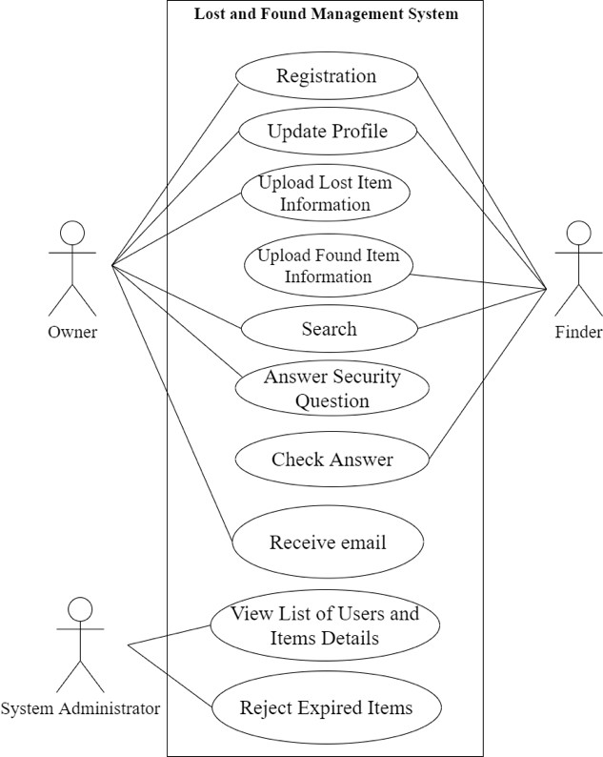

**Figure 2: FindMe Application Use Case Diagram**

### **4.1.3 Flowchart**

The system flow chart shows the overall structure of the system that will be developed, as well as the process of each function present in the system. Figure 3 shows the flow chart of the FindMe application.

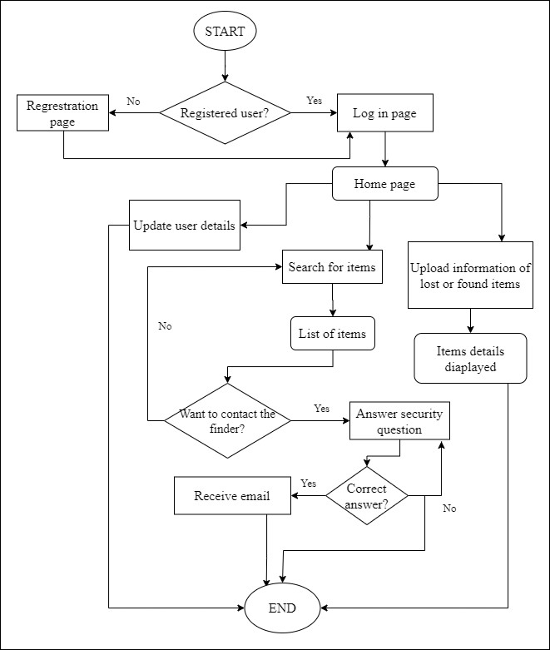

**Figure 3: FindMe Application Flow Chart**

### **4.1.4 Data Flow Diagram**

The data flow diagram shows the overview and description of the data flow process of a system. Figure 4 shows the data flow diagram of the FindMe application.

System users can be divided into two categories, which are the finder and owner of items. They can upload their personal information and update their profile. The data is stored in the Profile database. Next, the owner of the items can get information about the items from the Items database, which is uploaded by the finder.

Finders can get the answers to security questions answered by the owner of the items from the database answers. System administrators can get information about the list of users as well as items uploaded by users from the Profile and Item database. The information on items that are not expired is stored again in the Items database.

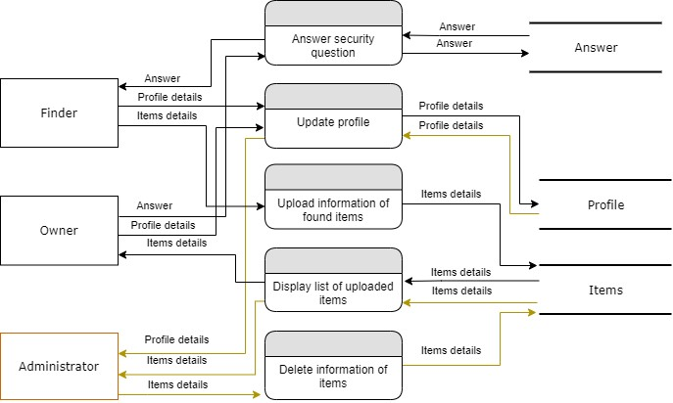

**Figure 4: Data Flow of FindMe Application**

Schematic Diagram

The schematic diagram for the Lost and Found Management System shows the following components:

- User interface

- Database

- Matching algorithm

- Notification system

- Communication module

*UML Diagrams*

The UML diagrams for the Lost and Found Management System are as follows:

*Use Case Diagram*

The use case diagram shows the interactions between the system and its users. The diagram includes the following use cases:

- Register user

- Report lost item

- Report found item

- Match item

- Notify and communicate between parties

- Retrieve and return item

*Class Diagram*

The class diagram shows the static structure of the system, including the classes, attributes, and relationships between them. The diagram includes the following classes:

- User

- Item

- Report

- Match

- Notification

*Sequence Diagram*

The sequence diagram shows the dynamic behavior of the system, including the interactions between objects over time. The diagram shows the sequence of events for the following scenarios:

- Reporting a lost item

- Reporting a found item

- Matching an item

- Notifying and communicating between parties

- Retrieving and returning an item

*State Machine Diagram*

The state machine diagram shows the different states of an object and the transitions between them. The diagram shows the states and transitions for the following objects:

- Item (lost, found, matched, returned)

- Report (submitted, processed, matched, closed)

- Match (pending, confirmed, rejected)

*Activity Diagram*

The activity diagram shows the flow of activities and actions within the system. The diagram shows the activities and actions for the following scenarios:

- Reporting a lost item

- Reporting a found item

- Matching an item

- Notifying and communicating between parties

- Retrieving and returning an item